Contact  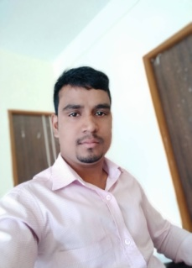  Ayodhya Nagar Raipur Chhattisgarh  House no. 1096  Mob. no.  +917223955332  E-mail.-  bhksahu92@gmail.com  OBJECTIVE  To apply my knowledge in practical fields. To full extent and thereby rendering a fruitfully growth to the organization as well as my professional carrier.  Hobbies  Chess  Carrom  Driving |  | BHAGWAT KUMAR  SAHU  D.O.B. -15 JUL 1992  EDUCATION  Govt. Hr. Sec. School TEKARI(ABHANPUR) RAIPUR CHHATTISGARH  I HAVE PASSED MY H.S.C. IN THE YEAR 2008 WITH 77.16 %  I HAVE PASSED MY H.S.S.C. IN THE YEAR 2010 WITH 89.60%  BHILAI INSTITUTE OF TECHNOLOGY, RAIPUR CHHATTISGARH  2012 - 2016  I HAVE PASSED MY GRADUATION B.E.(CIVIL) WITH 75.41%(HOUNORS)  WORK EXPERIENCE  M/s. REAL VALUE INFRACON (B-CLASS CONTRACTOR’S AND ENGINEER)  09/2018–Present  - Working as a Billing engineer  - Monitoring and execution of work as per structural drawing  - Quantity calculation for Tendering (BOQ)  - Knowledge of SOR for QC  M/s. YOGITA CONSTRUCTION  06/2017–08/2018  - Responsible for managing building projects from proposal to construction and then to completion. Analysing related risks.  - Work as a Site and Billing Engineer.  - Working experience under RAIPUR NGAR NIGAM  KUNAL BSBK Pre Cast  06/2016–06/2017  - Responsible for making decision that will have a direct impact on a Civil Engineering project.  - Monitoring in Erection of pre cast building elements.  - Billing of sub contractors  SKILLS  - Software known - Auto Cad -2D, Word, Excel , Power point  - Language known – HINDI, ENGLISH, LOCAL LANGUAGE

BHAGWAT KUMAR SAHU

