Ravi Patkar

Dear Hiring Manager,

Thank you for the opportunity to apply for the your company. After reviewing your job description, it's clear that you're looking for a candidate that is extremely familiar with the responsibilities associated with the role, and can perform them confidently. Given these requirements, I am certain that I have the necessary skills to successfully do the job adeptly and perform above expectations.

I am a hard-working professional who has been consistently praised as detail-oriented by my co-workers and management. Over the course of my career, I've developed a skill set directly relevant to the management and administration role you are hiring for, including value management. Overall, I have consistently demonstrated creative thinking, communication and technical and management abilities in every aspect of my at , and I invite you to review my detailed achievements in the attached resume.

After reviewing my resume, I hope you will agree that I am the type of competent and competitive candidate you are looking for. I look forward to elaborating on how my specific skills and abilities will be fit your organization. Please contact me at [9926108167] or via email at (ravipatkar46@gmail.com) to arrange for a convenient meeting time.
Thank you for y our consideration, and I look forward to hearing from you soon.

Sincerely,
Ravi patkar

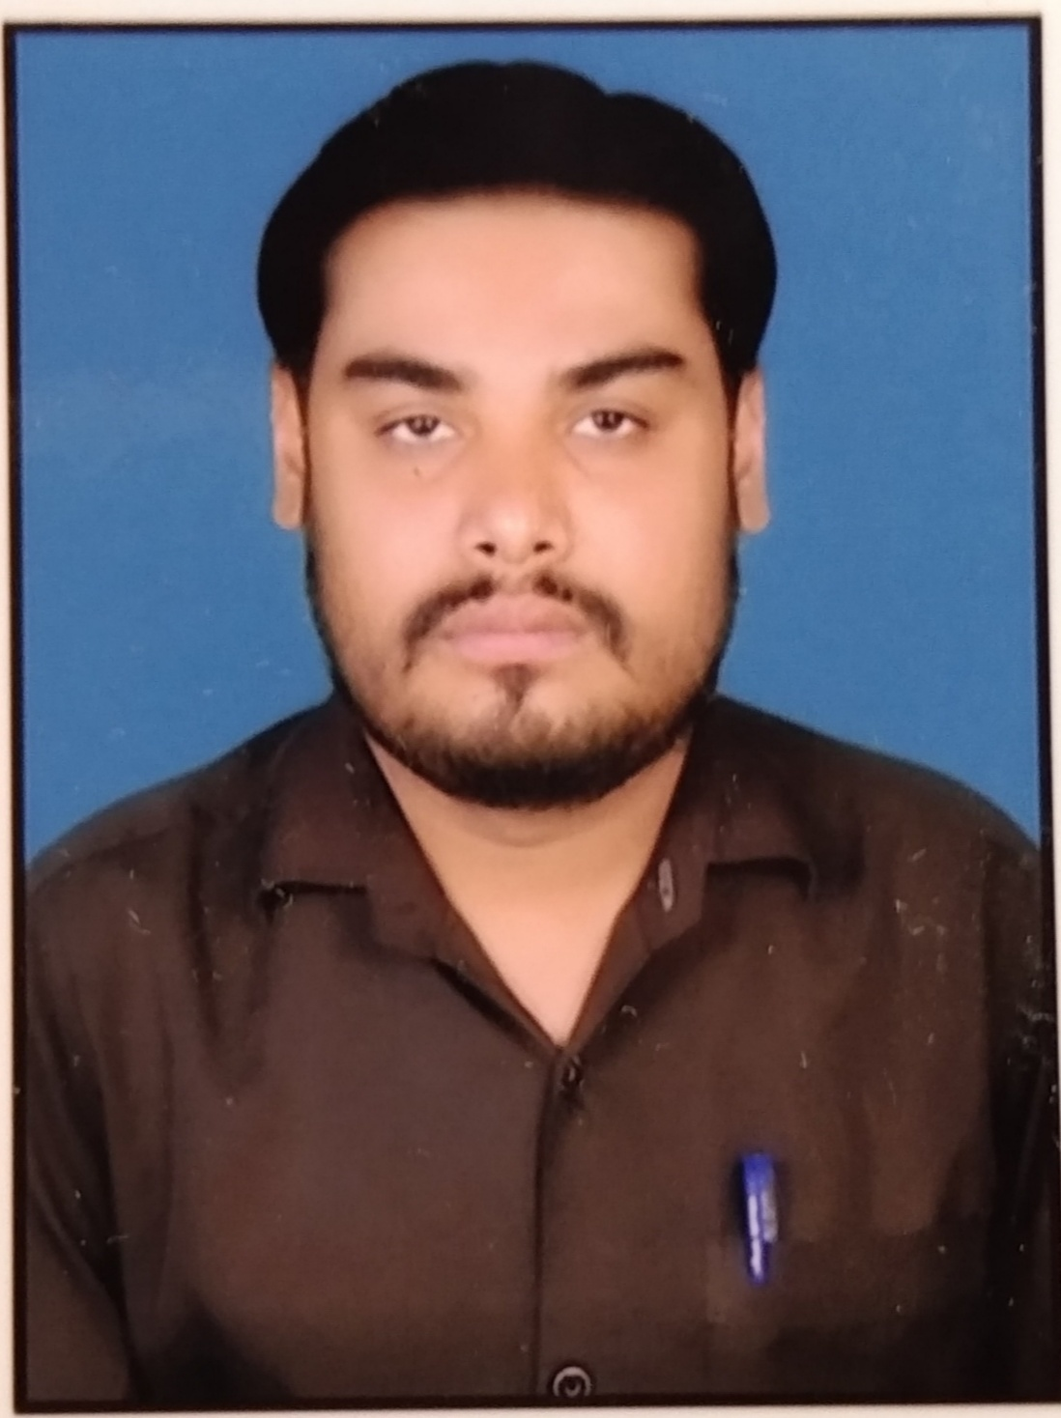
CURRICULAM VITAE

RAVI KUMAR PATKAR
Village– Khauli, P.O.- Khauli,
09926108167
Email Id – ravipatkar46@gmail.com

CAREER OBJECTIVE :-
To take up a challenging position in a organization of a repute that would encourage my personal growth besides utilizing my qualification and ability would give me an opportunity to serve as a valuable to the organization.

PERSONAL DETAILS :-

Name : Ravi Kumar Patkar Father’s name : Shri Sukhadev Patkar Mother’s name : Mrs. Surja Devi Patkar DOB : 04-02-1989
Contact no. : 9926108167

Marital status : married

Nationality : Indian

Language : Hindi, English, Chhattisgarhhi
Address : Village– Khauli, P.O.- Khauli, Thana-Kharora, Distt.-Raipur (C.G.) Pin - 493225

EDUCATION QUALIFICATION

Examination | Year | Board/University | Percent
10th | 2006 | C.G. Board Raipur | 63.00 %
12th | 2008 | C.G. Board Raipur | 69.00%
Tally | 2014 | NCVT | 61.00%
B.A. | 2017 | Pt. R.S.U. Raipur | 49.30%
M. A Hindi | 2019 | Pt. R.S.U. Raipur | 50.00%
MBA | 2020 | S.R.U. DHANELI RAIPUR | 72.00%

TECHNICAL EXPERTISE :
- Basic Knowledge Of Computer Application .
- Know Different Internet Application .
- Knowledge of Microsoft office (Excel, word, Power Point).
- Basic Knowledge of Tally.

STRENGTHS:
- Work With Positive Attitude To Contribute The Healthy Functioning Of The Organization.
- Self Confident And Great Patient.
- Analyzing Every Angle Of Project Before Working On It .
- Willingness To Work .
- Adaptability To Changing Environment

ADDITIONAL QUALIFICATION

International Correspondence Institute 01/04/202 - 93 %

DECLARATION

I have here by declared that above statement details are and certified. I assure you that I can do my ever just of my ability.

Date: ----------

Place: ---------- Ravi Kumar Patkar

