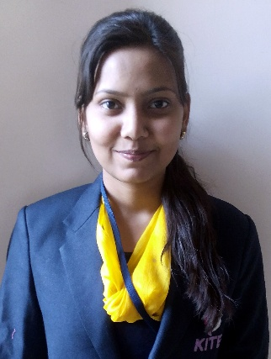Name- PRIYA SHARMA

*(B.E, Civil Engineering, 67.7 %, 2016,Pass-out)*

|  |  |  |
| --- | --- | --- |
| *Contact Address* | *Mail Id* | priyasharma8822@gmail.com |
| Bajrang nagar near mahavir aata chakki,Raipur,(C.G.),Pin Code-492001 | *Contact Phone* | 9009285982 |
| *Date of Birth* | SEP 21st ,1994 |

Career Profile

|  |
| --- |
| Objective |
| To work in the most challenging position with an organization that provides ample opportunities to learn and to contribute. |
| Educational Qualification |
| **Bachelor of Engineering (B.E) in Civil Engineering** (2012-2016) fromKRUTI INSTITUTE OF TECHNOLOGY AND ENGINEERING RAIPUR,CSVTU UNIVERSITY,CHHATTISGARH,INDIA |
| **Experience** |
| **Back office executive at Orvolo Venture Pvt Ltd.** |
| **3 years of teaching experience at couching institute (aaptitute & reasoing)** |

Technical Skills

|  |  |
| --- | --- |
| Tools & Packages | MS-Office, AutoCAD, STAADPRO |

Academics­­­­­­­­­­­­­­­­­

|  |  |  |  |  |
| --- | --- | --- | --- | --- |
| Qualification | Institute | Board | Year of Study | Percentage |
| **B.E (Civil)** | KRUTI INSTITUTE OF TECHNOLOGY AND ENGINEERING RAIPUR, | Chhattisgarh Swami Vivekananda Technical University BHILAI (C.G.) INDIA | 2012-2016 | **67.8%** |
| **XII** | MAYARAM SURJAN HIGHER SECONDARY SCHOOL | Chhattisgarh Board of Secondary Education | 2011-2012 | **69.9%** |
| **X** | R.K. SINDHI HIGHER SECONDARY SCHOOL | Chhattisgarh Board of Secondary Education | 2009-2010 | **83%** |

Thesis/Projects/Training

|  |  |
| --- | --- |
| B.E Mini Project | |
| Title | STUDY OF LOW COST HOUSING IN RURAL AREA |

|  |  |
| --- | --- |
| B.E Major Project | |
| Title | ANALISIS OF METHODOLOGY OF AFFORDABLE HOUSING |

|  |  |
| --- | --- |
| Vocational Training | |
| Activities | PUBLIC BUILDING |
| Duration | 30 days |
| Company | PWD RAIPUR |

|  |  |
| --- | --- |
| Training | |
| Activities | CONSTRUCTION OF BUILDING |
| Duration | 30 days |
| Company | PWD RAIPUR |

Personal Details

|  |  |
| --- | --- |
| Sex | FEMALE |
| Father’s Name | Mr. NANDKISHORE SHARMA |
| Nationality | INDIAN |
| Marital Status | UNMARRIED |
| Languages Known | HINDI,ENGLISH |

DECLARATION

I, hereby affirm that the particulars furnished are true to the best of my knowledge.

Place: **RAIPUR**  **PRIYA SHARMA**

Date: